UML DIAGRAMS

**Date**: [16-06-2024]

**Use Case Diagram**

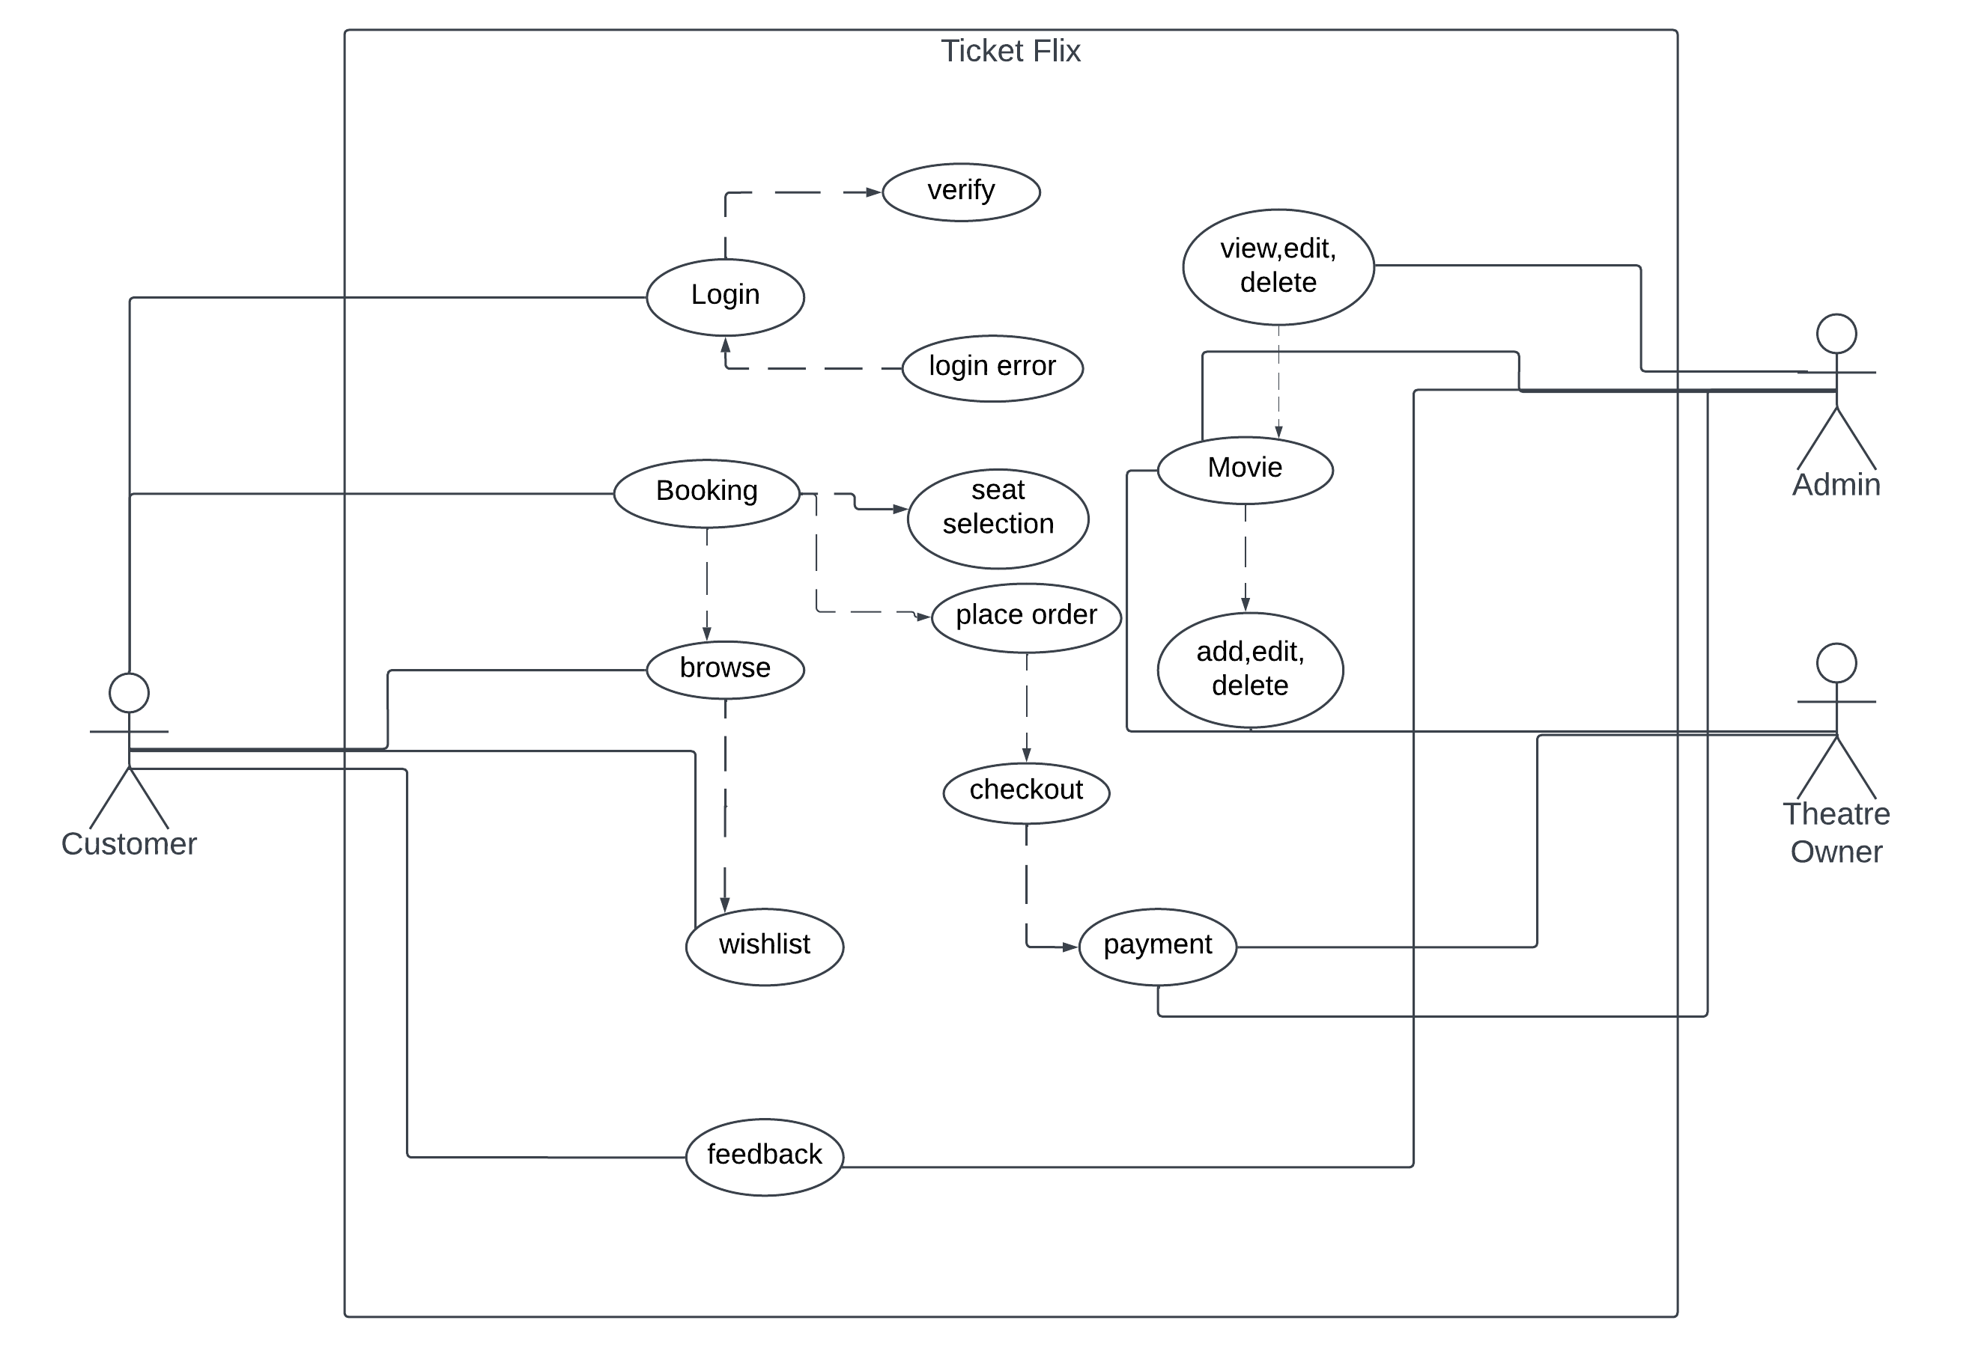

**Activity Diagram Admin**

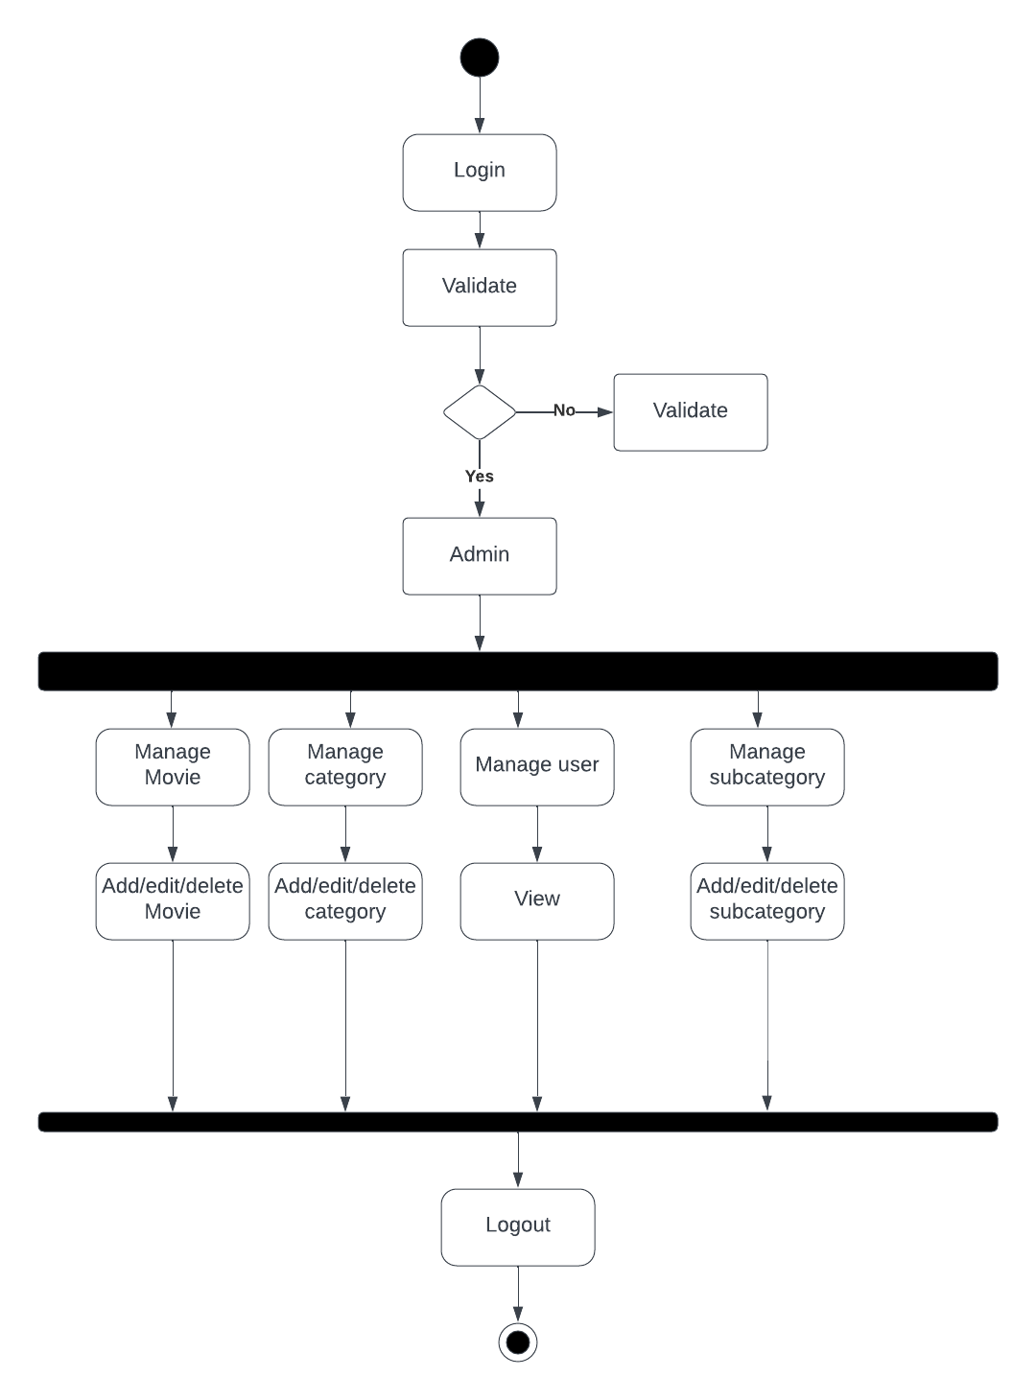

**Activity Diagram User**

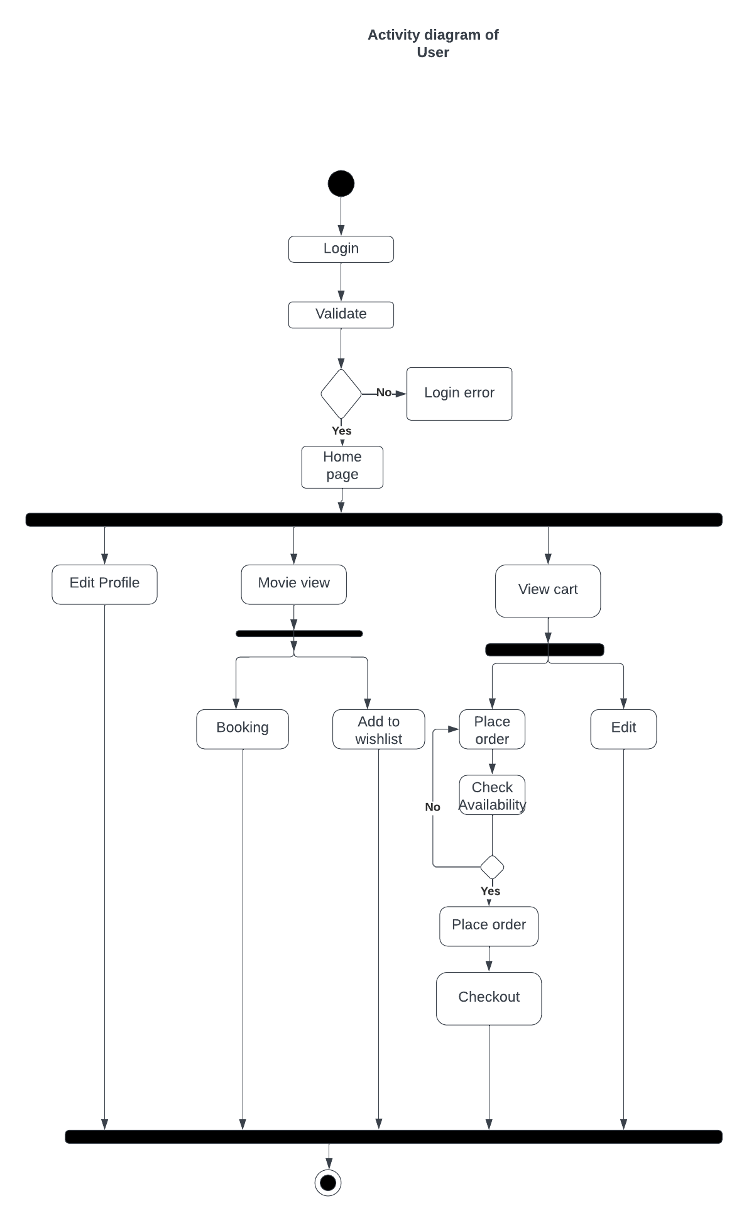

**Activity Diagram Theatre Owner**

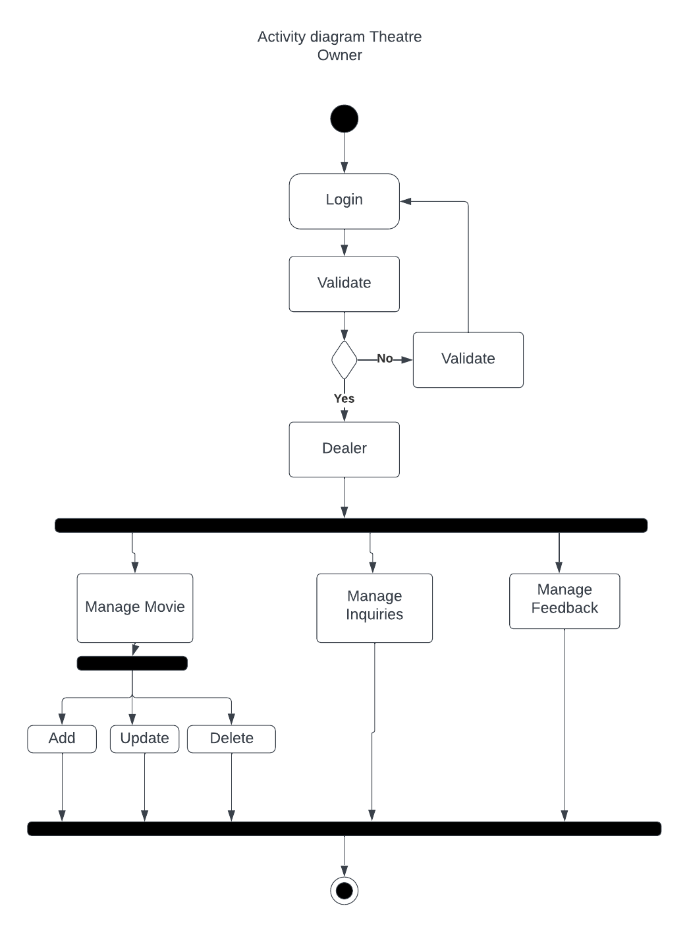

**Sequence Diagram**

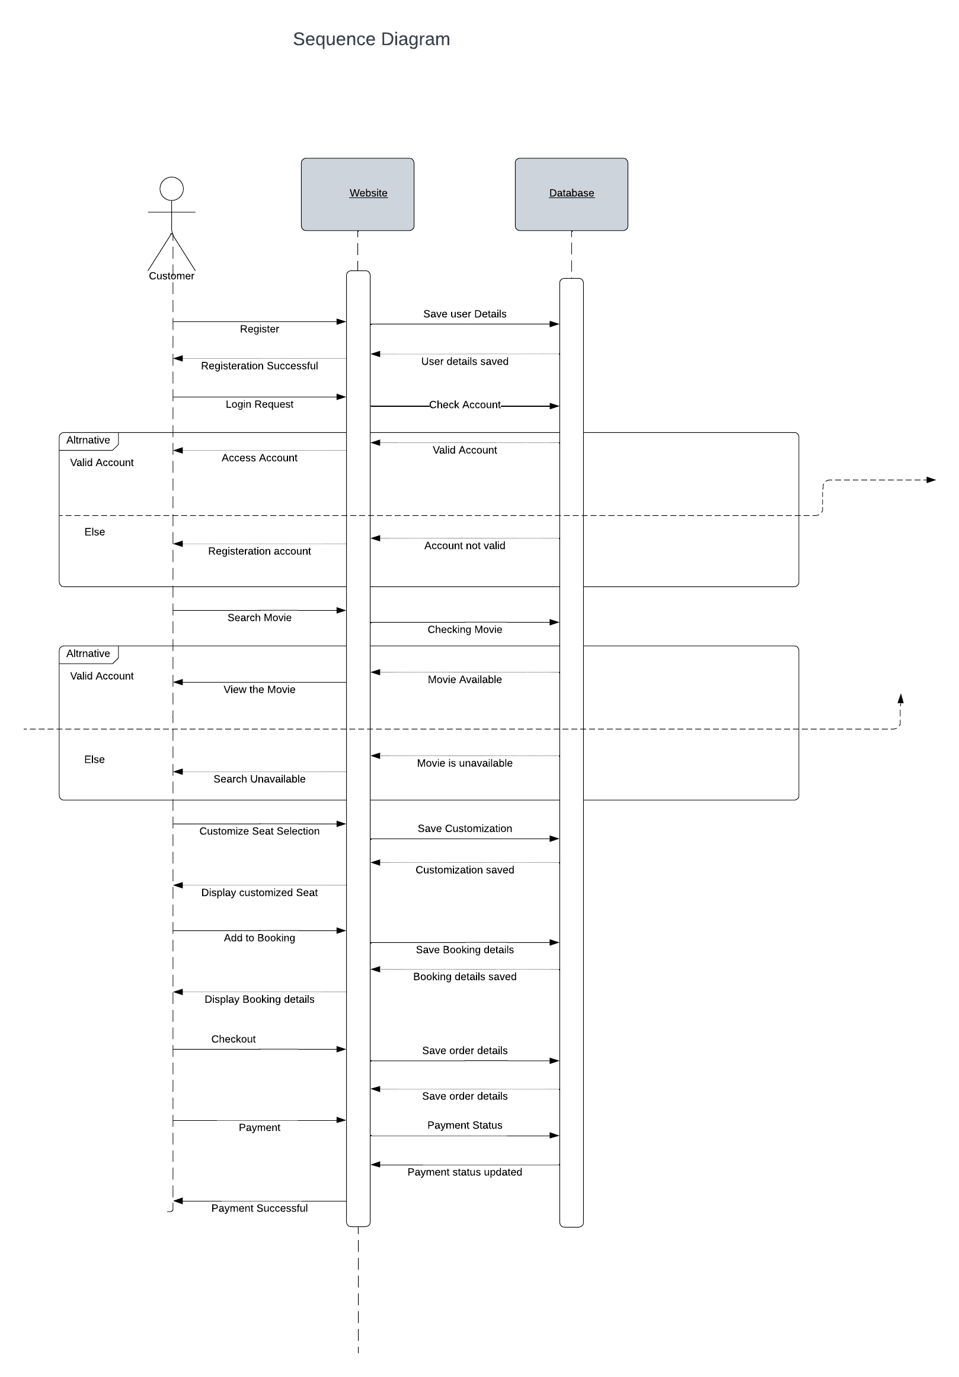

**Class Diagram**

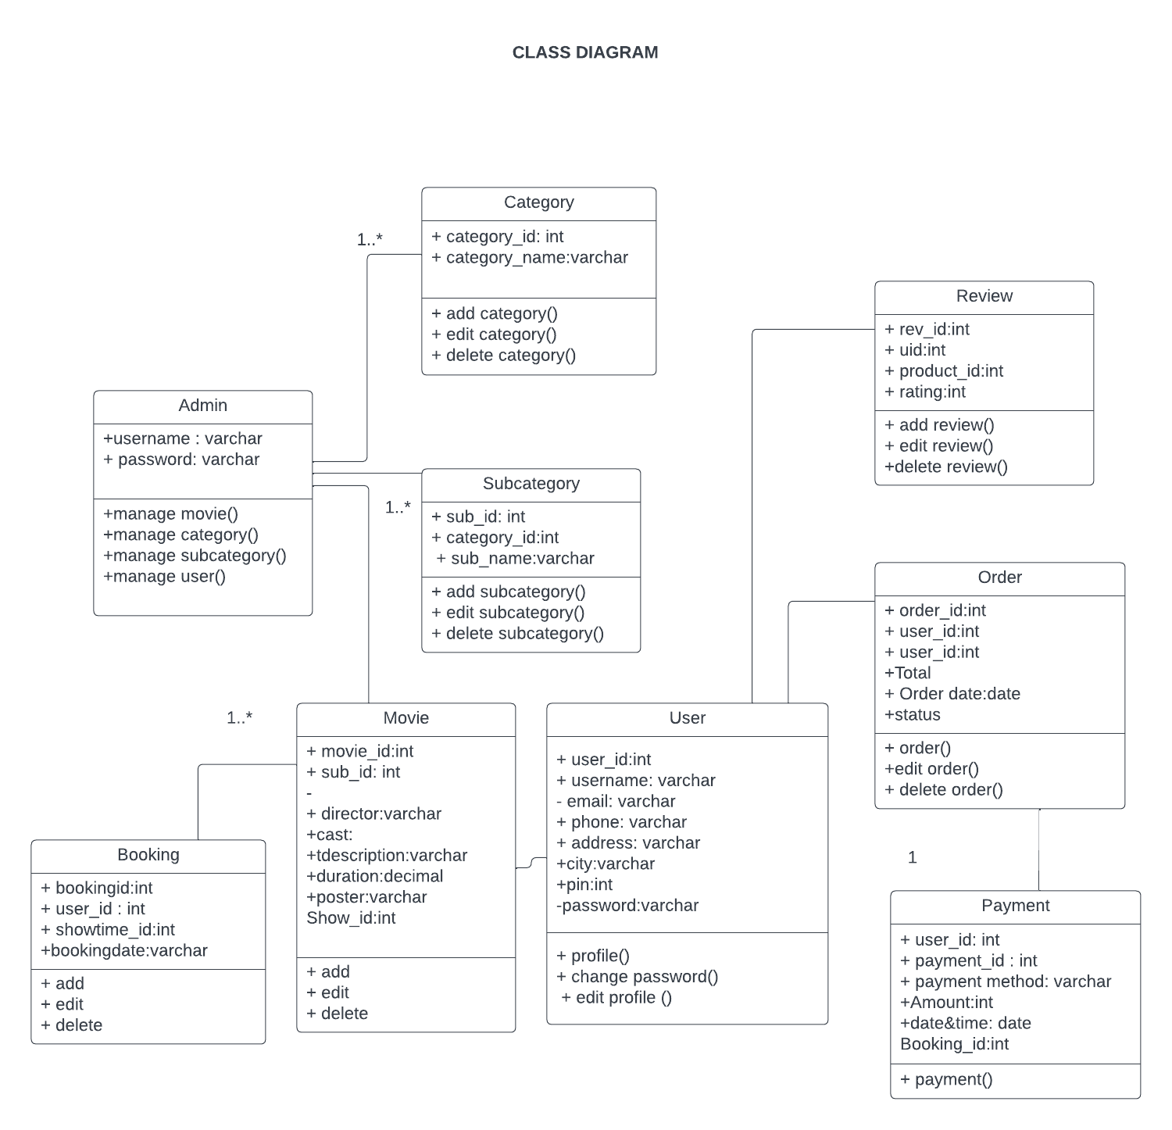

**Object Diagram**

